**ANL 488 PROJECT PROPOSAL**

**RENEWABLE ENERGY GENERATION AND DEPENDENCY IN SINGAPORE**



**Submitted by**

**LOW PEI XUAN**

**SCHOOL OF BUSINESS Singapore University of Social Sciences**

**Presented to Singapore University of Social Sciences in partial fulfillment of the requirements for the  
Degree of Bachelor of Science**

**2023**

Table of Contents

Introduction 1

BusinessProblem 1

BusinessAnalyticsProblem 2

Literature Review 2

Regressionmodels 2

ArtificialNeuralNetwork *(*ANN*)* 3

TimeSeriesAnalysis 3

Data Understanding and Preparation 5

DataUnderstanding 5

Table 1: Data Dictionary for Structured Data 6

DataPreparation 6

Singapore’sElectricityConsumptionDataset 7

Singapore’sRenewableElectricityGeneratedDataset 12

Singapore’sTotalPopulationDataset 18

Proposed Modelling and Evaluation 23

ARIMAMODEL 24

HOLT’SMETHOD 25

ModelComparisonTable 25

Proposed Schedule 27

References 28

**Project Title: Renewable energy generation and dependency in Singapore**

# **Introduction**

Global warming and climate change has been a persistent dire matter for decades now, and with technology taking the world over, the situation will only worsen as electricity consumption continues to rise with the use of technology in our daily lives. There is no doubt that electricity plays an important role in a nation’s economic productivity and with the increase in electricity demand worldwide, the primary resources used to generate electricity is depleting at an alarming rate that give rise to both economic and environmental concerns. (Yoo, S.-H. ,2006 ; Kuo, 2019)

Now then, how can we continue to consume high volumes of electricity while limiting the impacts it will have on the environment? The answer is the adoption of renewable electricity (RE). Renewable electricity as its name suggests refers to electricity produced from renewable sources that are easily reproducible in short periods of time, for example electricity generated from indefinite solar power. (Shinn, 2022) As the generation of electricity from renewable sources produces less harmful emissions like Carbon Dioxide (CO2) and Sulfur dioxide (SO2) etc, it is considerably more environmentally friendly. However, Singapore’s main electricity source today still comes from non-renewable sources such as natural gases. (Powering Lives, 2023)

## ***Business Problem***

As resources are depleting and electricity security is threatened, the objective of this study is to find out if Singapore is able to depend on renewable electricity in the future.

To deduce this, our study aims to predict Singapore’s renewable electricity generation level, electricity consumption level and population. These are the three important aspect to analyse and deduce if Singapore’s current level of electricity generated through renewable sources will increase in the future to supplement at least 60% of the nation’s electricity consumption level. This will shine light on whether Singapore’s renewable electricity supply is able to sustain the nation’s electricity consumption levels for the next decade to come.

## ***Business Analytics Problem***

The business analytics problem is to evaluate suitable modelling techniques that will help our study deduce Singapore’s dependency on renewable electricity through forecasting techniques applicable to predict Singapore’s electricity consumption, renewable electricity generated and population. The most ideal modelling technique for our datasets will then be further analysed and discussed.

# **Literature Review**

Being the most used energy source in Singapore, the consumption of electricity becomes a mixed blessing as it powers the nation’s economy but harms the environment in the long run. Hence, measures to ensure more usage of renewable electricity should be put in place to reduce the harm electricity consumption can have on the environment. Ever since the pandemic, there was an increase in the overall electricity consumption level in Singapore which leads to the pressing question: “Is the current renewable electricity supply rate in Singapore sufficient to feed the nation’s electricity consumption rate in the long run?”. (Goh, 2020) To answer this question, predictive analysis needs to be conducted to predict the nation’s population, level of electricity consumption and renewable electricity generation till 2030.

After reviewing literatures related to electricity consumption and energy dependency topics, most studies used predictive and time series models such as Regression, Artificial Neural Network (ANN), ARIMA and Holt’s Winter test on time series datasets. Hence, we will be reviewing each of these models and their respective literatures to identify the models used, their findings as well as potential loopholes not addressed by the literature reviews.

## *Regression models*

Rekhade, R., & Sakhare, D. K. (2021) conducted a research on sector-wide electricity consumption in India using 4 regression models namely, linear, logarithmic, power and exponential regression models. They collected and studied yearly data from 1970 to 2018 from sectors such as industry, domestic, agriculture, commercial, traction and railways. Among the 4 regression approaches which all proves to be accurate, exponential regression model performed the best with the lowest MAPE value. However, as this study solely focused on regression models, the study pointed out that future studies should include a variety of forecasting techniques such as ANN and time series models as well as other important factors affecting electricity consumption such as GDP and population.

## *Artificial Neural Network (ANN)*

In terms of variation, Pannakkong, W., Harncharnchai, T., & Buddhakulsomsiri, J. (2022) forecasted daily electricity consumption level in Thailand using a variety of forecasting methods such as Regression, Artificial Neural Network (ANN), Support Vector Machine, and Hybrid Models. Interestingly, it was concluded that the Hybrid Models comprising of 3 features, namely a hybrid Multiple Linear Regression (MLR), five ANN models tuned by sequential grid search, and national holiday indicator variables provided the best overall performance with the smallest MAPE value when compared to other traditional models alone. The variety of models explored in this study gave a good comparison between the accuracy of regression and ANN models. However, time series models was not discussed in this study to give a higher level of comparison between predictive models and time series analysis models.

Other than electricity consumption, another study adopted ANN to predict energy dependency based on sector-wide energy consumption. Sozen, A. (2009) predicted energy dependency in Turkey using numerical equations based on sectoral energy consumption and basic energy indicators. This study used 2 models containing main energy indicators and sectoral energy consumption to train the neural network. ANN was concluded to show high accuracy, making it possible to predict energy dependency from sectoral energy consumption.

Although ANN seem like a viable model to predict future energy consumption and dependency, our study would like to adopt a more interpretable model as performing analysis on the predicted data is important in this study.

## *Time Series Analysis*

As time series data are used in studies related to electricity consumption and energy dependencies, there is no doubt that time series models should be considered when predicting future electricity consumption, renewable energy generation and population.

In a study conducted by Manni, U. H., & Datuk. Dr. Kasim Hj. Md. Mansur. (2022), Holt-winters’ test is adopted to predict the renewable power capacity and generation in Indonesia to estimate if the nation is able to reach its SDG7 goal by 2030. Both the additive and Multiplicative method were conducted where the additive method proves to work better with the given dataset. It was concluded that Indonesia’s existing renewable power capacity and generation rate is unable to reach the nation’s SDG7 objective by 2030 although an increase in the power capacity and generation level was predicted. The Holt-winters’ time series model is concluded as a highly effective predictive tool in this study where a decision tree regression model is used to further improve the model’s accuracy that is validated using the ACF and Ljung-box tests. As this study also only focuses on one time series model, it lacks comparability between different time series models.

Asadi, M., Larki, I., Mohammad, M. F., Ahmadi, R., & Farajollahi, M. (2023) used time series algorithms of ARIMA, single exponential smoothing and Holt to predict electricity consumption, population and CO2 emissions from power plants in Iran. Among the 3 algorithms used, the Holt method returns the lowest MAPE % when predicting on electricity consumption. The ARIMA model is deemed as the best performing model when predicting both the population and CO2 emission. As this study is the only study closely related to our study in terms of variables to be predicted, results and result interpretation, our study will be taking this study into account and implementing similar models into Singapore’s context to achieve the goal of our study.

Although the above-mentioned studies were able to successfully predict energy consumption using the various models, little to no literature we have come across, conducted studies on renewable energy dependency on a highly-developed country like Singapore who faces many challenges in renewable energy generation options. As our study aims to see if Singapore’s current efforts in generating renewable electricity is able to produce enough electricity in the future for future consumption, it is a question about time. Hence, time series modelling is picked to be the models used in this study.

Hence, our study serves to determine which time series model will be the best suited model in predicting 3 datasets namely, Singapore’s electricity consumption, Singapore’s renewable energy generation and total population. The results derived from this study will value-add this highly buzzed about but rarely explored sector (Renewable energy) in Singapore which is crucial in helping Singapore anticipate the sustainability of renewable electricity and realise actionable steps to safeguard electricity security for future generations. By identifying the various research gaps in above-mentioned studies, we are able to realise suitable models required and compare them to gain insights on Singapore’s electricity consumption and renewable electricity generation capacity to determine the nation’s dependency on renewable energy.

# **Data Understanding and Preparation**

## ***Data Understanding***

In this study, 3 datasets consisting of data related to Singapore’s electricity consumption, renewable electricity generated and total population will be examined.

These datasets were retrieved namely from Singstat, sourced from Energy Market Authority Singapore (EMA) and the World Bank, sourced from International Energy Agency (IEA Statistics). Singstat is the nation’s statistical office where official statistics are being collected and compiled. (Department Of Statistics Singapore, 2023) The source of the data from singstat is provided by EMA which is the nation’s power system operator, energy industry developer and Singapore’s energy industry regulator. (Energy Market Authority, 2023) The World Bank works in major area of developments around the world, they compile officially-recognised international sources. (The World Bank, 2023) The particular source of data we are using in our study comes from the IEA statistics, which is an organisation that works with governments and industries on sustainable energy projects. (Iea, 2023)

The 3 datasets consists of the following properties:

|  |  |  |  |  |
| --- | --- | --- | --- | --- |
| Dataset | Variable | Definition | Value | Time Period in Dataset |
| Electricity_Consumption  _1971_2014.csv | Electricity Consumption | Amount of electricity consumed measured in Kilowatt-Hour (kWh) | 1154.81 to  8844.69 kWh, NA | 1961 to 2022 |
| Electricity_From  _Renewables_new.csv | Renewable Electricity Generated | Electricity production from renewable sources in Kilowatt-hour (kWh) | 85000000.00 to  918000000.00 kWh, NA | 1960 to 2022 |
| Total_Population  _Column.csv | Singapore’s Population | The number of people residing in Singapore in plain number. | 1,022,100 to 5,637,022 | 1950 to 2022 |

### *Table 1: Data Dictionary for Structured Data*

## ***Data Preparation***

In order to prepare data for modelling, the above-mentioned datasets has to be cleaned for more accurate predictions. As these datasets came in an excel spreadsheet (.xlsx) together with other fields that are irrelevant to our current study, these variables are extracted from its raw excel spreadsheet into new CSV files that contains only the necessary variables respectively. These variables are also restructured from being in rows to now columns, making it readable in the python programme.

Hence, the study will be looking into these 3 excel spreadsheets, each containing 2 columns - Years and the respective variables (Electricity Consumption, Renewable Electricity Generated and Singapore’s population).

As we are dealing with time series data, the following are the steps needed to clean a time series data before modelling:

1) Handling missing or null values

2) Check for stationarity

3) Removing trend

4) Removing Seasonality

5) Ensure stationarity

Let us look at how each dataset was prepared for modelling.

### **Singapore’s Electricity Consumption Dataset**

#### 1) Handling Missing / Null Values

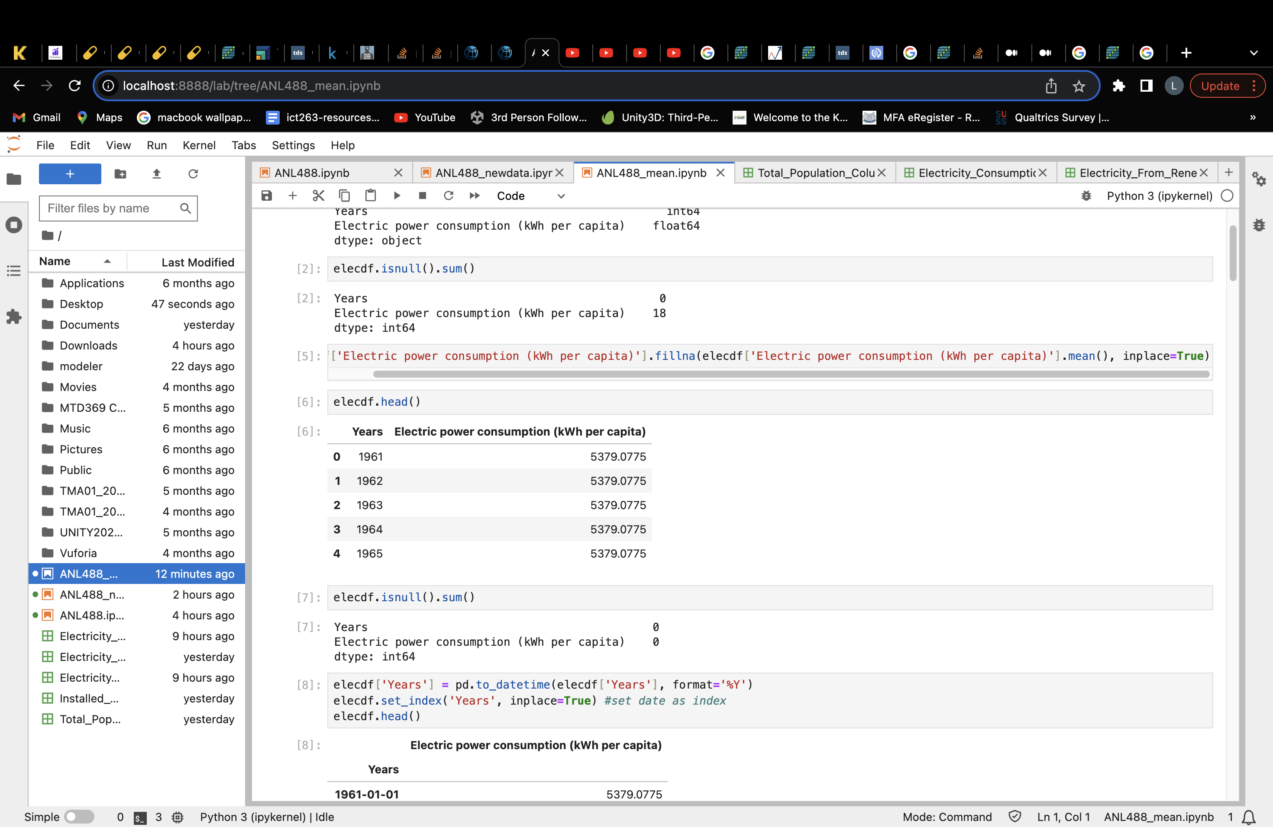

##### *Figure 1.1: Null values present in electricity consumption dataset*

As the electricity consumption dataset contains missing values, the values spanning from 1961 to 1970 and 2015 to 2022 would be removed. It is important to replace or remove missing data as most machine learning algorithms cannot handle a dataset with missing values and it can cause deviation of results which is unfavourable for modelling and prediction. (Kumar, 2022) Here, null values are chosen to be discarded rather than replaced because these missing values are in consecutive periods spanning from 1961 to 1970 where measures to collect electricity consumption data might not have been put in place yet as Singapore was only founded in 1965. As this dataset was collected and consolidated in 2014, the missing values from 2015 to 2022 might suggests that they are data not yet collected by the source.

When missing values in this dataset was attempted to be replaced by mean, the dataset presented biasness and was not able to obtain stationarity. Hence, the missing values in this dataset is discarded for better prediction results.

Below shows the removal of null values present in the electricity consumption csv file.

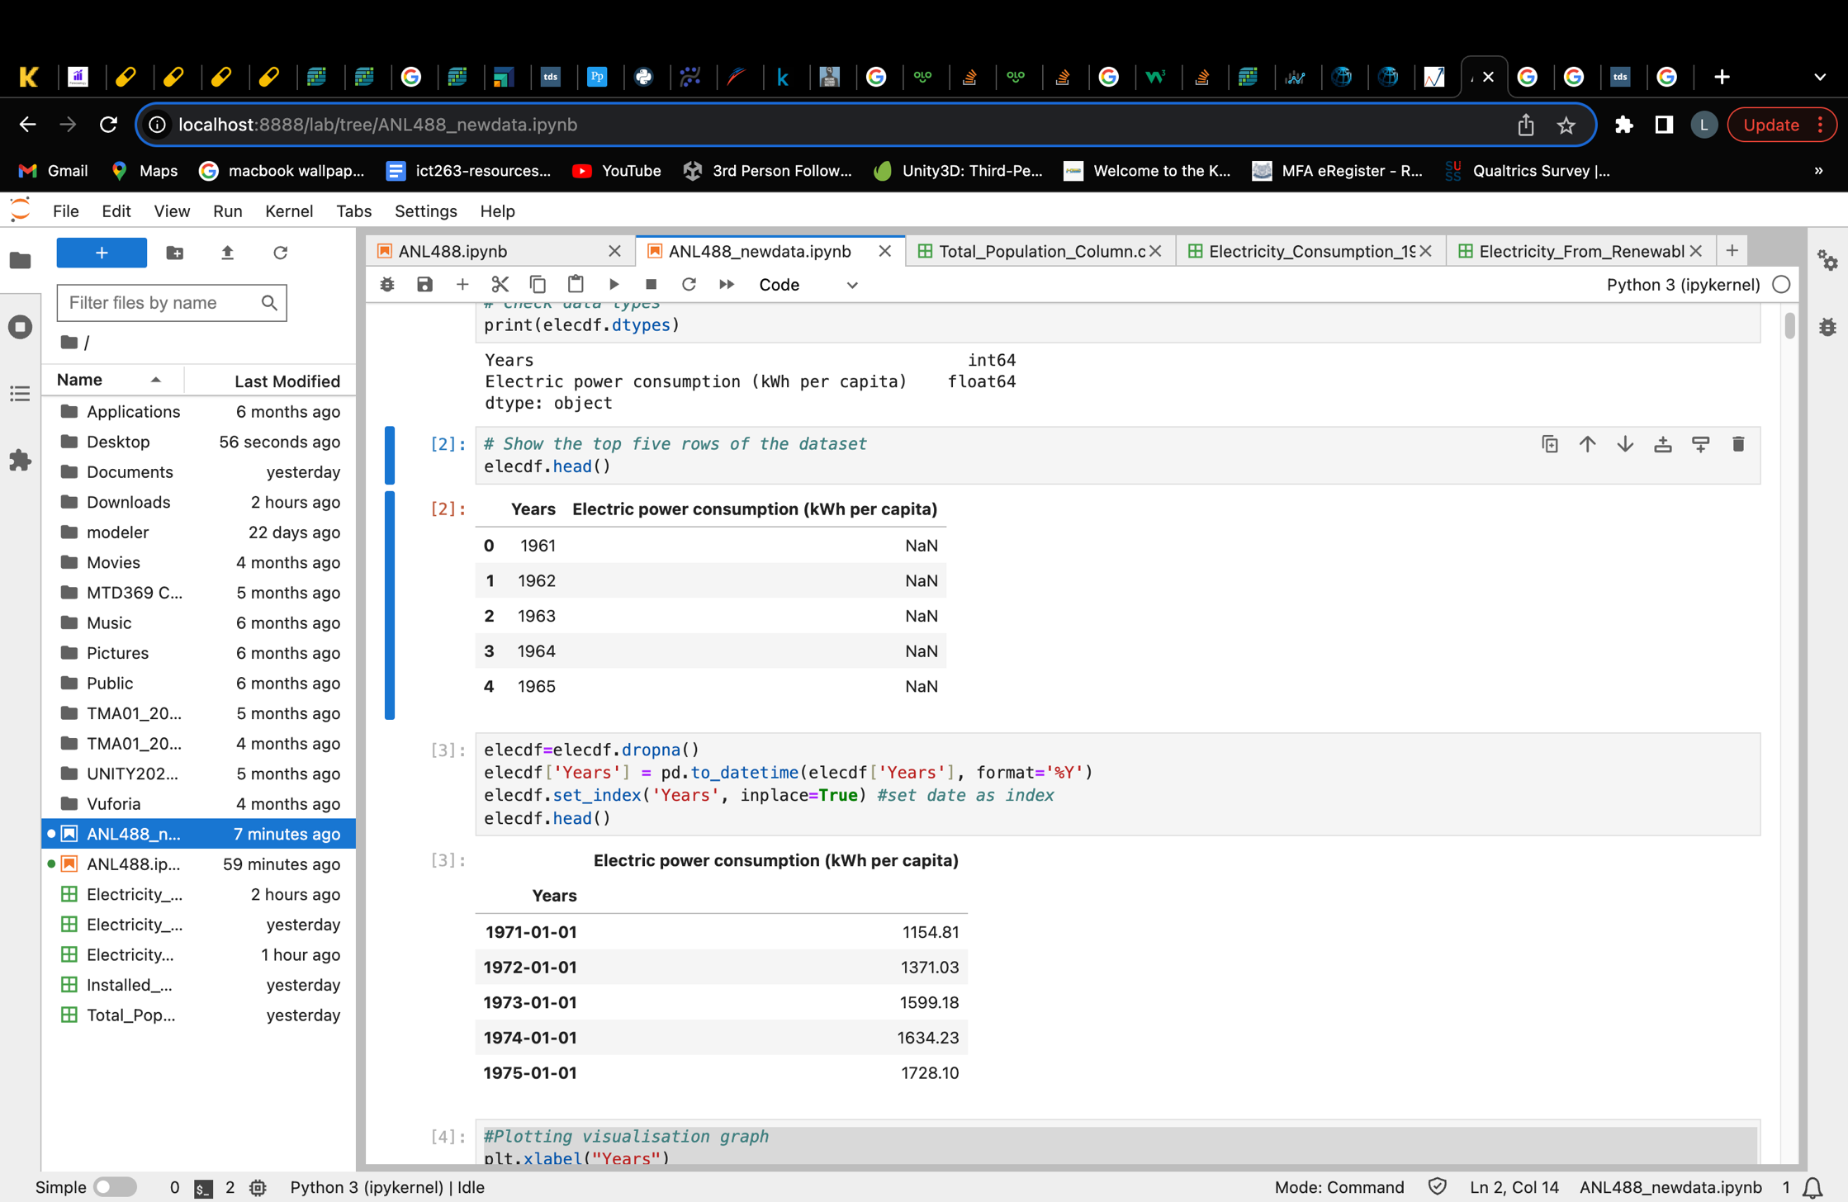

##### *Figure 1.2: Removing null values from “Electricity_Consumption_1971_2014.csv” file*



##### *Figure 1.3: Checking for null values in electricity consumption dataset after removal*

After removing the null values from the dataset, the original dataset with 2 columns and 62 rows is reduced to 2 columns and 44 rows of data. It consists of Kilowatts-hour (kWh) of electricity consumed in Singapore from years 1971 to 2014.

After dealing with missing values, we will do a simple check on the stationarity of the dataset to determine if the dataset is ready for modelling.

#### 2) Checking for Stationarity

Stationarity in a time series data would suggest that statistical properties are constant, and do not change over time. (G, 2023) Stationarity is crucial as most time series models rely on this aspect and assumes each time point is independent of one another with constant mean and variance over time. (Rasheed, 2020) Hence, it is important for a dataset to achieve stationarity before it can be used for modelling.

Here, we conduct a simple dickey fuller test to determine if the dataset is stationary.

*Checking Stationarity* ***before*** *differencing*

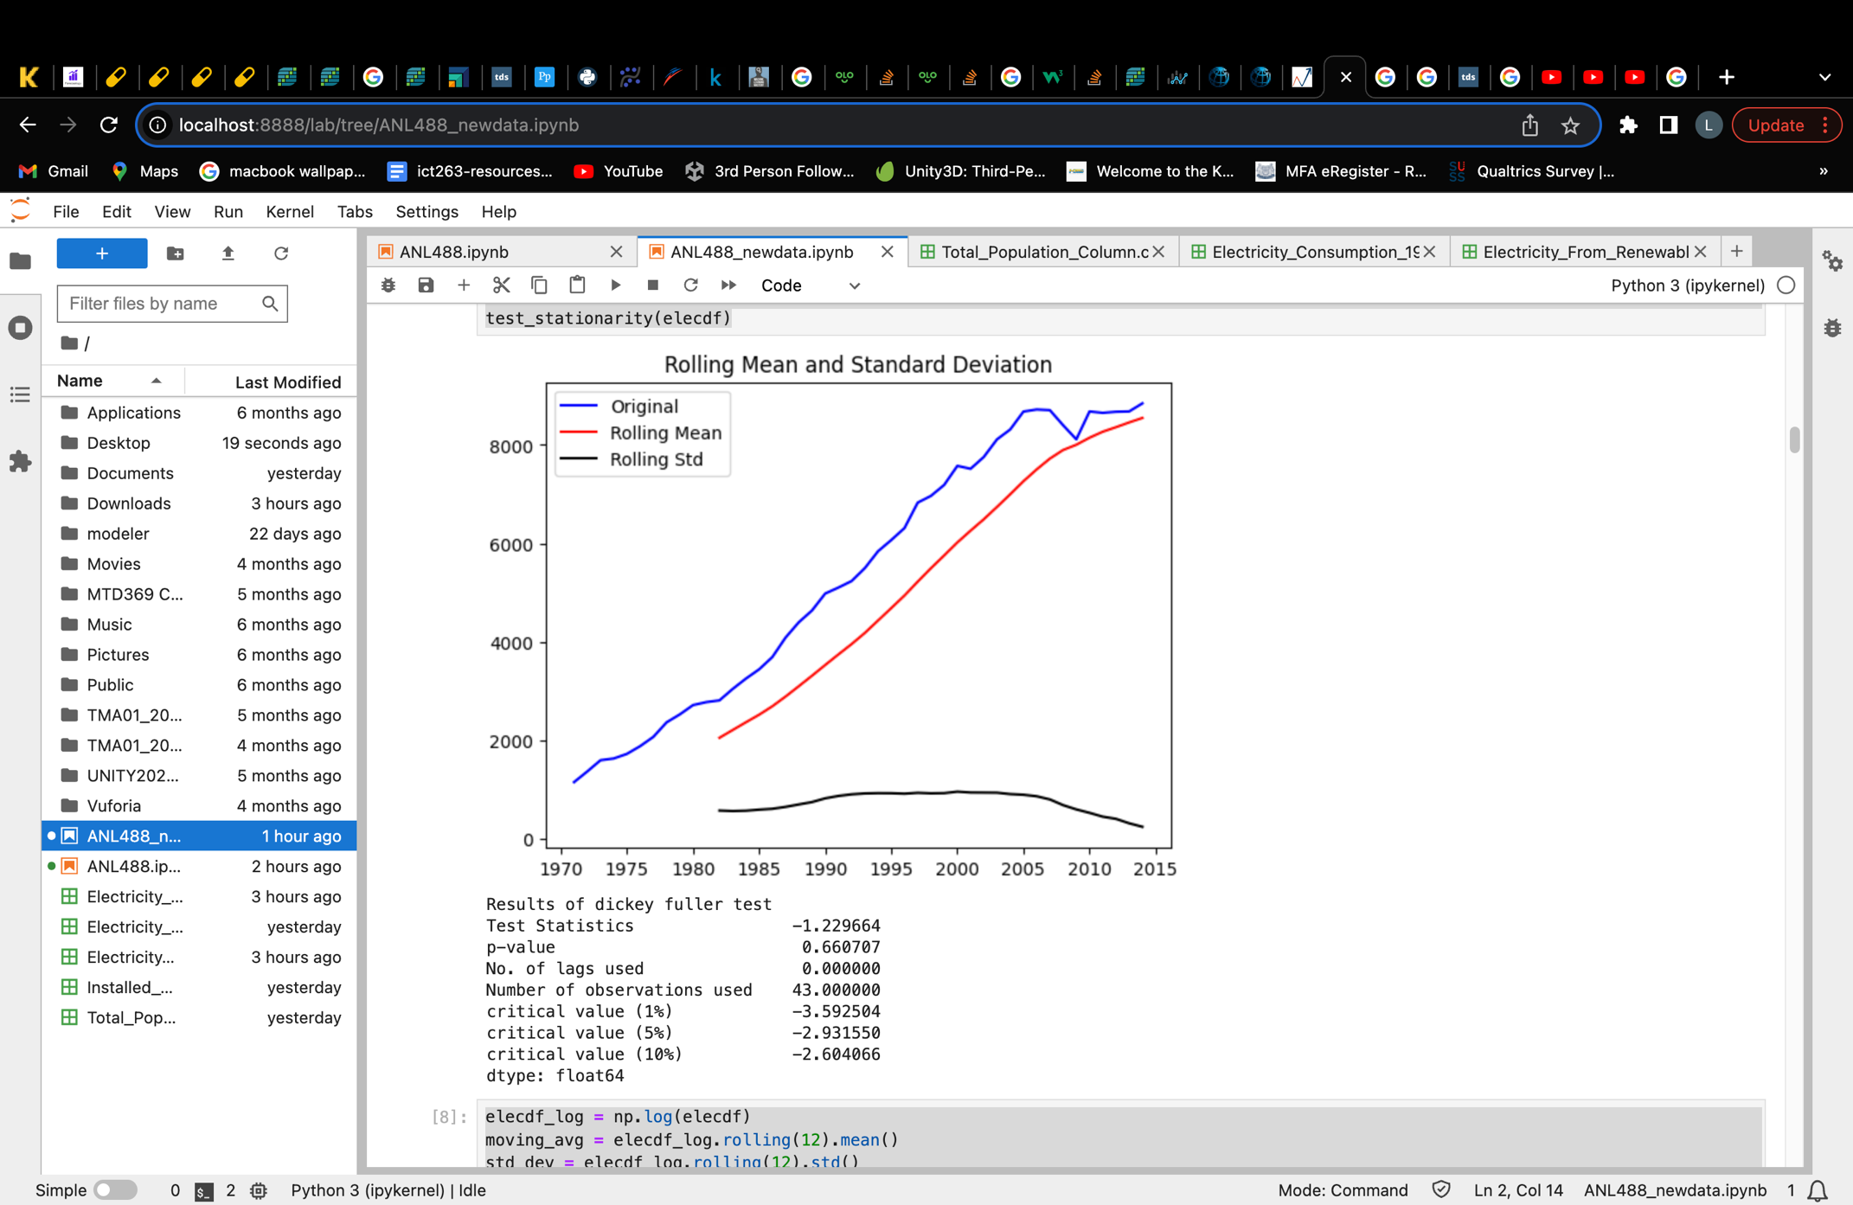

##### *Figure 1.4: Checking for stationarity in dataset before attempting to remove trend*

Figure 1.4 shows the results of the dickey fuller test conducted to investigate if the dataset is stationary before taking steps to ensure its stationarity. From the results, we can deduce that the dataset is not stationary.

This can be seen firstly, from the visual graph that this data has an upward trend.

Secondly, we can deduce stationarity from the p-value generated. This p-value determines if my null hypothesis of H0 = Data is not stationary is to be rejected or not. Rejecting the null hypothesis would mean that this data is stationary. To decide whether to reject the hypothesis, we will see if the p-value is <= 0.005. As 0.005 is our significance level, any p-value that is lesser than 0.005 would lead us to reject the hypothesis and deduce the data as stationary. However, since the p-value generated in figure 1.4 is greater than 0.005 at 0.67, we would not reject the hypothesis and this data is thus not stationary.

Lastly, we can also determine if the data is stationary by looking at whether the test statistics value is smaller than the critical values. If the test statistic value is smaller, it would mean that the data is stationary. However, in our case the test statistics is bigger than all 3 critical values, hence indicating that the data is not stationary.

After deducing that the data has a trend and is not stationary, we will be using differencing in an attempt to remove the trend present and achieve stationarity for this dataset.

#### 3) Removing trend

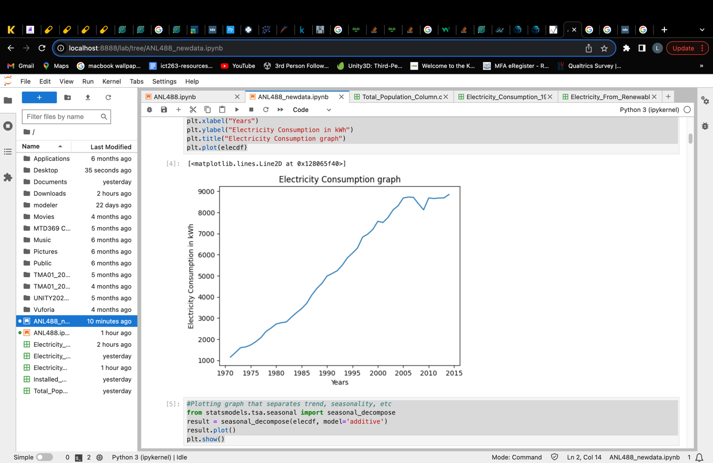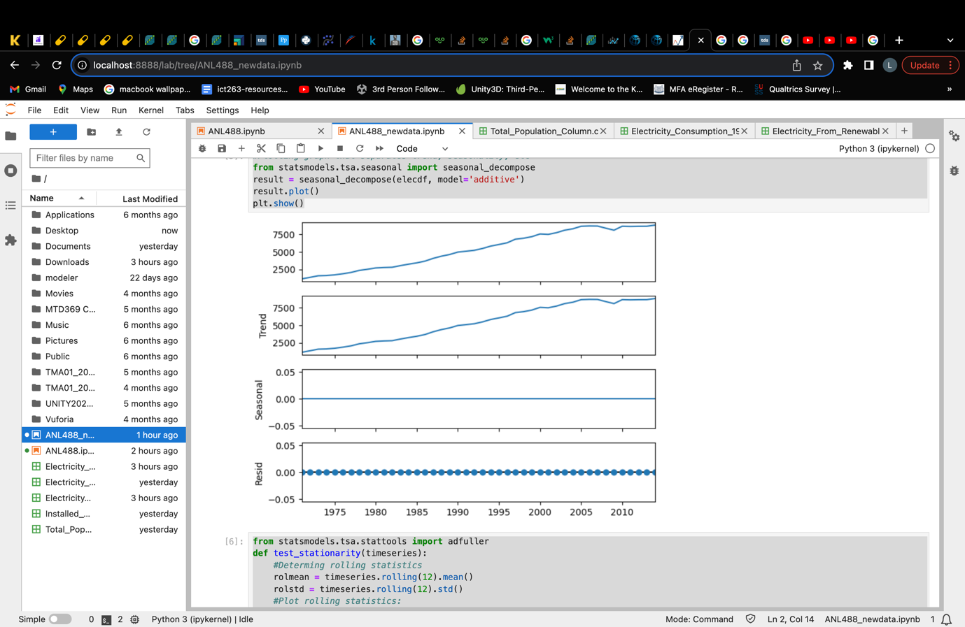

##### *Figure 1.5: Electricity consumption dataset visualisation graph*

Figure 1.5 shows the data presented visually on the left and seasonally decomposed to identify possible trends and seasonality on the right. From here, we can see that the data does consists an upward trend. However, it does not contain seasonality which is expected, as this dataset contains yearly data that will unlikely show seasonality.

Additive decompose was chosen here because the data does not have seasonality, hence, additive decompose would be more suitable as seasonality here does not change in relation to time. (PennState, 2023)

Hence, to remove the trend present, we conducted first order of differencing on the electricity consumption dataset. Differencing is one of the common method used to remove trend from a data. It works by stabilizing the mean of the data series over time by subtracting observations from a previous time period. (Brownlee, 2020) This ensures that the mean of data will not be increasing or decreasing forming a trend, hence removing the possible trend present in data.

|  |  |
| --- | --- |
| P-values **before** differencing   | P-value **after** 1st First Order Differencing   |

##### *Table 2: Electricity consumption p-value after 1st and 2nd order of differencing*

Table 2 shows the p-value results obtained before and after the first order of differencing using both the Augmented Dickey-Fuller (ADF) test and Kwiatkowski-Phillips-Schmidt-Shin (KPSS) test. As we previously discussed, the ADF test allows us to reject the null hypothesis of H0 = data **is not** stationary when p-value is <= 0.005 significance value. KPSS on the contrary allows us to reject the null hypothesis of H0 = data **is** stationary if the p-value is <= 0.005. So in order for data to be stationary under the KPSS test, the p-value has to be bigger than 0.005.

After the first order of differencing, the electricity consumption data returns a p-value of 0.000 for ADF test and 0.100 for KPSS test. This shows that the data is now stationary with the p-value from both tests indicating that the data is stationary. (The p-values here are only displayed to 3 decimal place)

#### 3) Removing Seasonality

After removing the trend present, seasonality needs to be taken care of. However, as the electricity consumption dataset contains only yearly data, seasonality will not be present. This can be further supported by figure 2.2 where the seasonality in the seasonally decomposed graph on the right shows a straight line. Hence, as seasonality is not present in this data, there will be no need to perform steps to remove seasonality.

#### 4) Ensuring Stationarity

After removing possible trend and seasonality, we have to ensure that the data has indeed achieve stationarity. To do so, a simple ADF test is performed to ensure that the p-value is lower than the significance level of 0.005.

*Checking for stationarity* ***after*** *differencing*

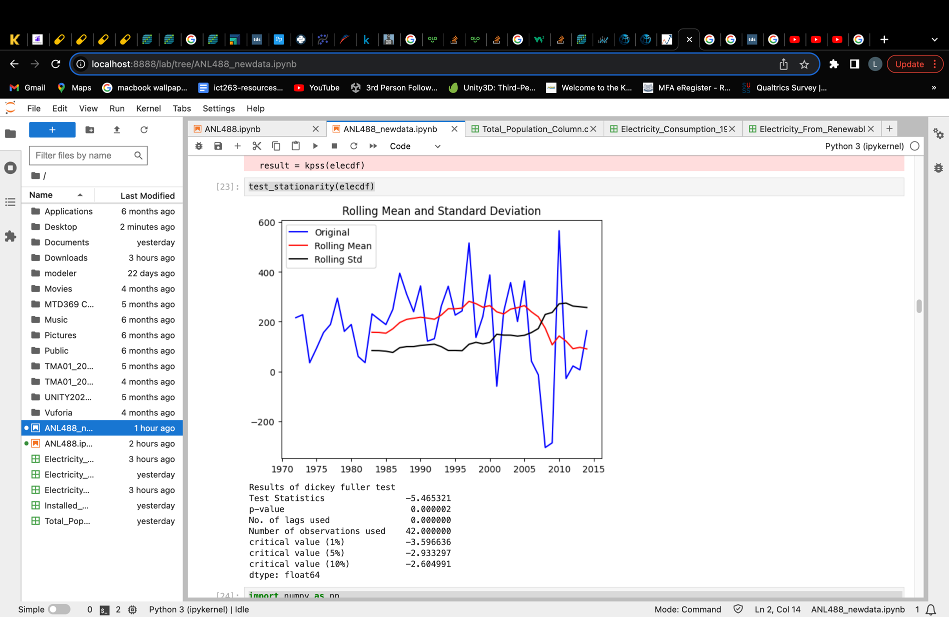

##### *Figure 1.6: Checking electricity consumption dataset for stationarity after 1st order differencing*

Compared to figure 1.4, figure 1.6 visually shows less of a upward trend. The p-value now is also smaller than 0.005 at 0.000002. The test statistics value of -5.465321 is also smaller than all 3 critical values. Hence, this suggests that this data is now stationary and ready for modelling.

### **Singapore’s Renewable Electricity Generated Dataset**

#### 1) Handling missing or null values

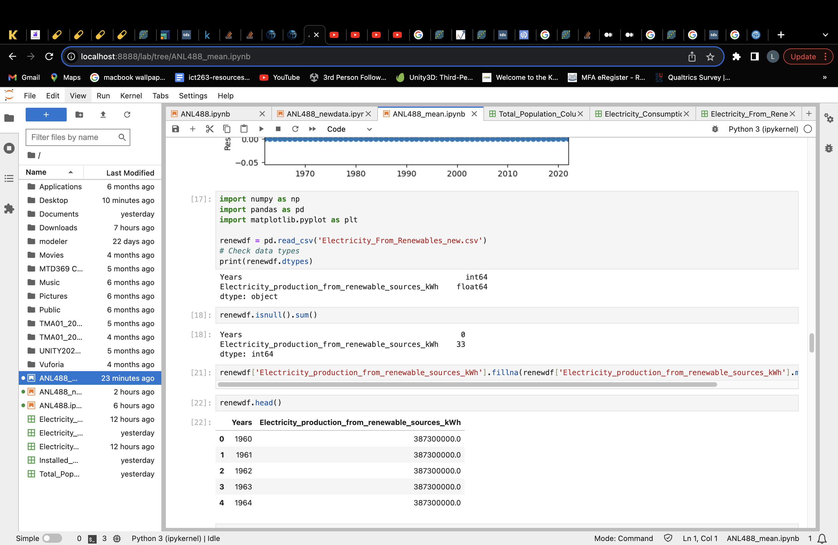

##### *Figure 2.1: Null values present in renewable electricity dataset*

Similar to the electricity consumption dataset, this data also has missing values that are not random spanning from 1960 to 1985 and 2016 to 2022. Since these values are not missing in a random order from the dataset, they will be discarded rather than replaced.

As missing values amounted to slightly more than 50% of the dataset, missing values in this dataset was attempted to be replaced by mean. However, the data was unable to achieve stationarity as the replacement of the missing values seem to have created biasness in the dataset and causing ADF test’s p-value to shoot up. Hence, missing values will be discarded instead.

The data missing from the time periods may be due to Singapore only generating renewable electricity from 1986 onwards. Missing values from 2016 to 2022 might suggest that they are data not yet collected by the source.

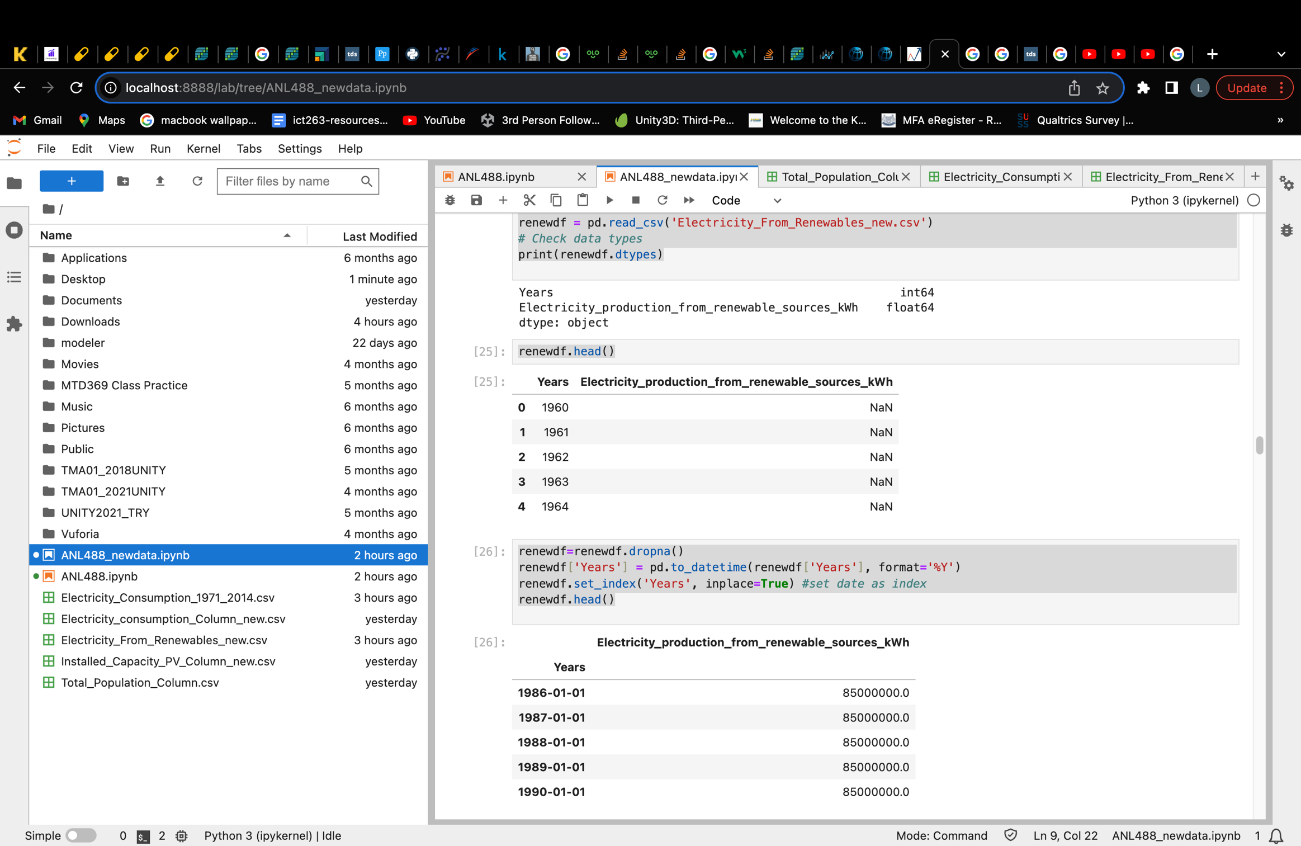

##### *Figure 2.2: Removing null values from “Electricity_From_Renewables_new.csv” file*

Figure 2.2 shows the presence of null values in the dataset. We can also observe that the time element of the data is set to index in python in order to make the dataset applicable for forming a time series model.

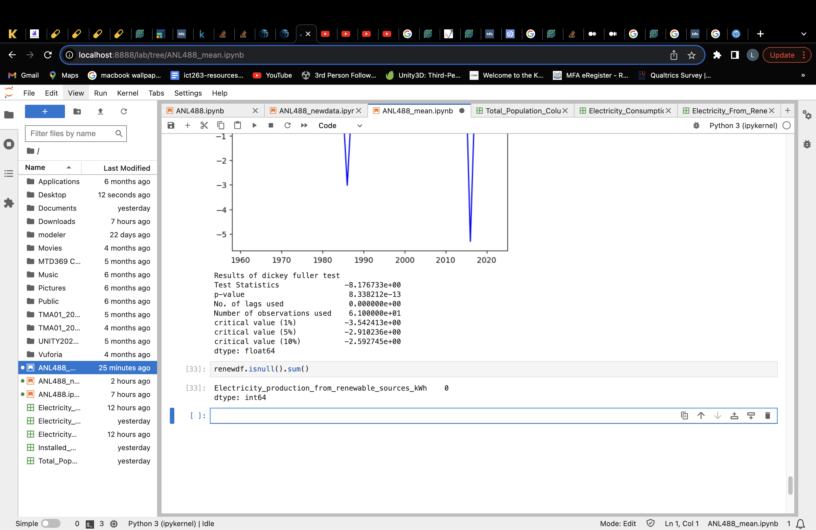

##### *Figure 2.3: Checking for null values in renewable electricity dataset after removal*

After removing the null values from the dataset, the original dataset with 2 columns and 63 rows is reduced to 2 columns and 30 rows of data. It consists of Kilowatts-hour (kWh) of electricity generated from renewable sources in Singapore from years 1986 to 2015.

After dealing with missing values, we will do a simple check on the stationarity of the dataset to determine if the dataset is ready for modelling.

#### 2) Check for stationarity

*Checking for stationarity* ***before*** *differencing*

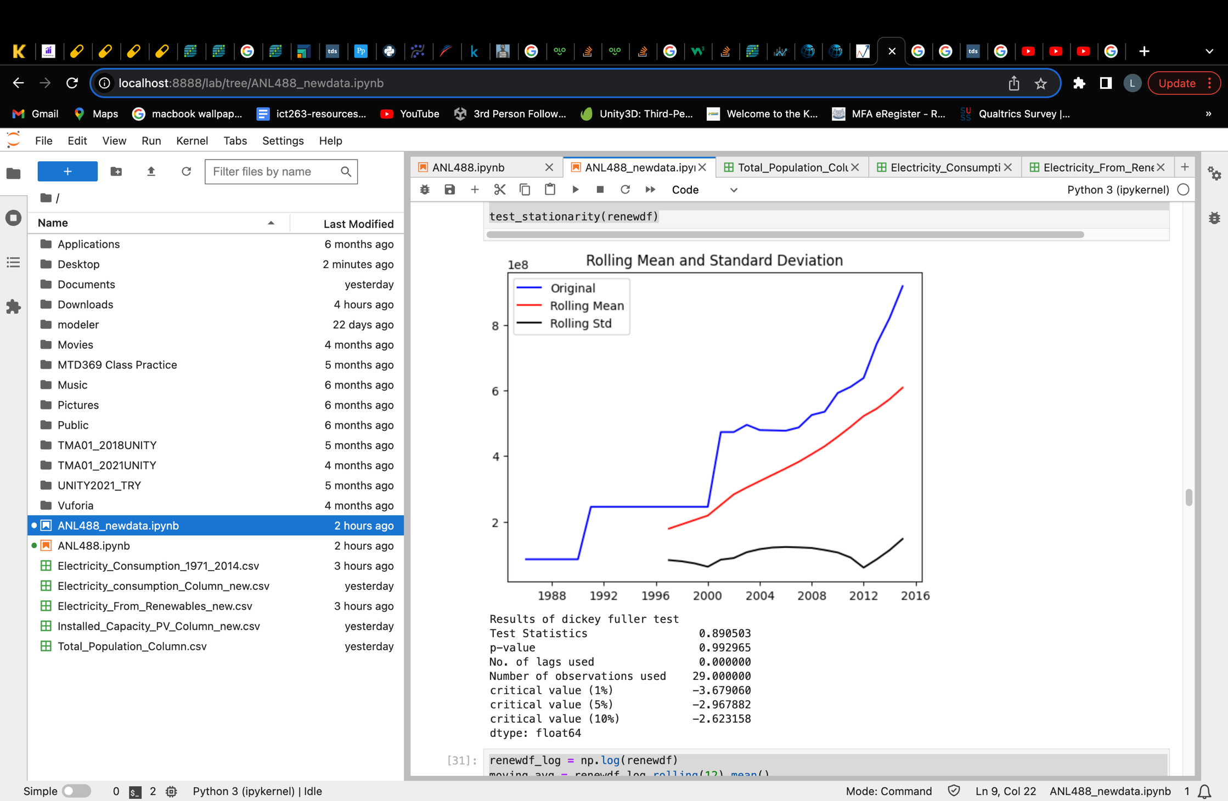

##### *Figure 2.4: Checking renewable electricity dataset for stationarity before differencing*

Figure 2.4 shows the results of the dickey fuller test conducted to investigate if the dataset is stationary before taking steps to ensure its stationarity. From the results, we can deduce that the dataset is not stationary.

This can be seen firstly, from the visual graph that this data has somewhat an upward trend. This can be seen more clearly in the rolling mean line on the graph.

Secondly, we can deduce stationarity from the p-value generated where it is greater than the significance value 0.005. Thus, we would not reject the hypothesis and this data is thus not stationary.

Lastly, we can also determine if the data is stationary by looking at whether the test statistics value is smaller than the critical values. Here, the test statistics is much bigger than all 3 critical values, hence indicating as well that the data is not stationary.

After deducing that the data has a somewhat trend and is not stationary, we will be using differencing in an attempt to remove the trend present and achieve stationarity for this dataset.

#### 3) Removing trend

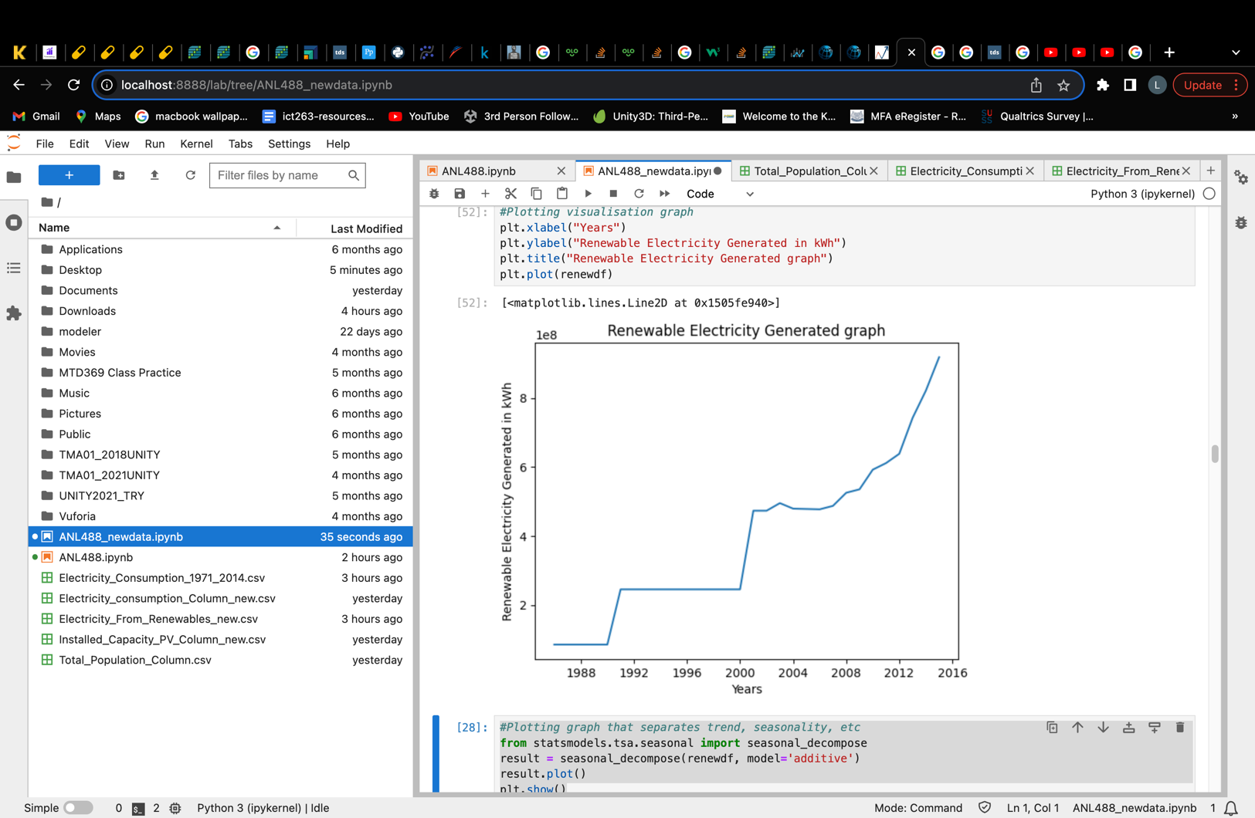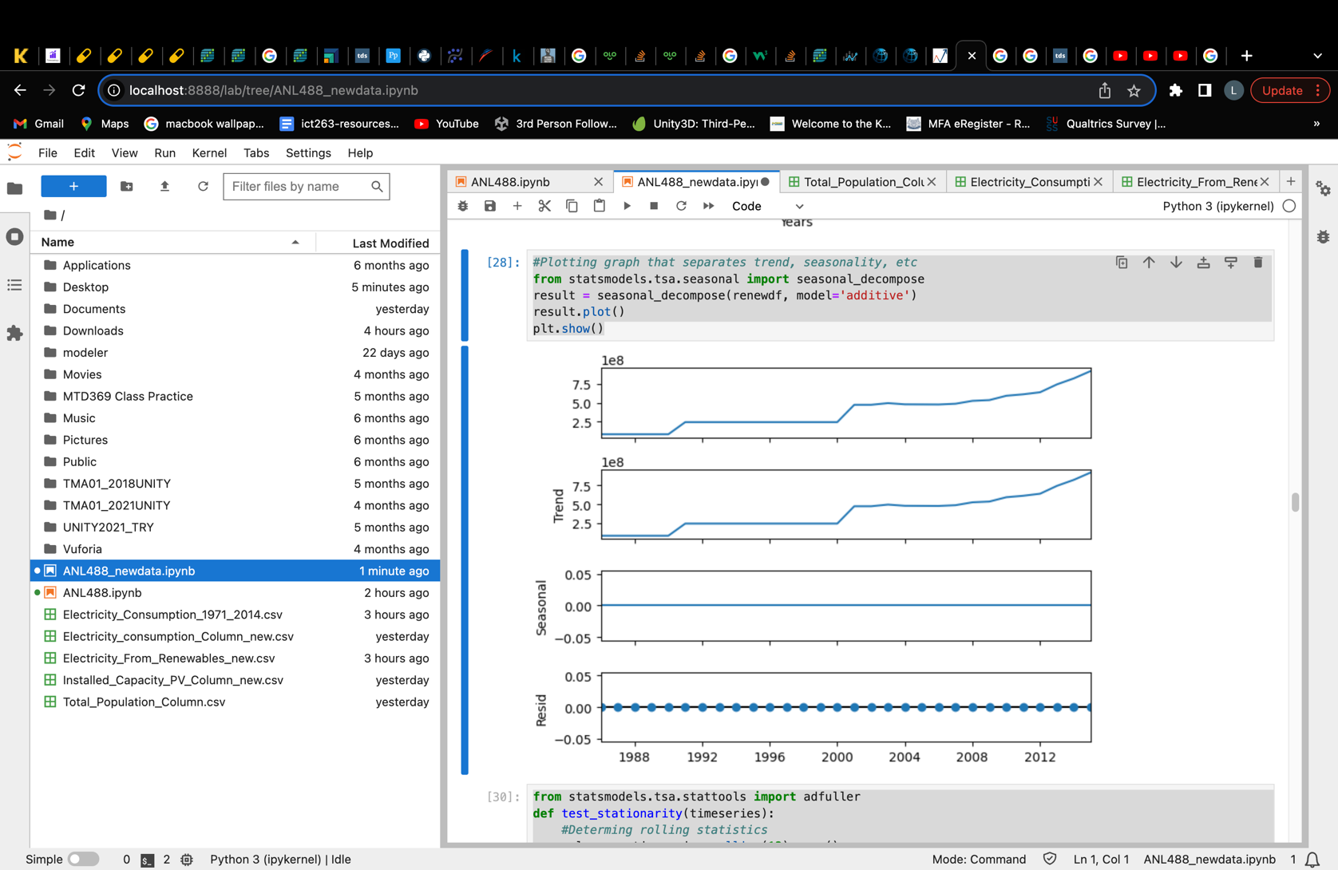

##### *Figure 2.5: Renewable electricity generated dataset visualisation graph*

Figure 2.5 shows the data presented visually on the left and seasonally decomposed to identify possible trends and seasonality on the right. From here, we can see that the data does somewhat consists an upward trend especially towards the end of the graph. Seasonality is not see in the graph as expected, because this dataset contains yearly data that will unlikely show seasonality.

|  |  |
| --- | --- |
| P-value before Differencing   | P-value after first Order Differencing   |

##### *Table 3: Renewable Electricity data p-value after 1st and 2nd order of differencing*

To remove the trend present, we conducted first order of differencing on the renewable electricity generated dataset. Table 3 shows the p-value results obtained before and after the first order of differencing using both the Augmented Dickey-Fuller (ADF) test and Kwiatkowski-Phillips-Schmidt-Shin (KPSS) test. The results showed p-value 0.000 and 0.100 for both tests respectively.

This shows that the null hypothesis for both the ADF and KPSS tests are rejected and not rejected respectively. Hence, indicating that the data is now stationary. (The p-values here are only displayed to 3 decimal place)

#### 4) Removing Seasonality

After removing trend, seasonality needs to be removed as well, if applicable. However, as the renewable electricity generated dataset contains only yearly data, seasonality will not be present. This can be further supported by figure 4.5 where the seasonality in the seasonally decomposed graph on the right shows a straight line. Hence, as seasonality is not present in this data, there will be no need to perform steps to remove seasonality.

#### 5) Ensure stationarity

After removing possible trend and seasonality, we now need to ensure that the data has indeed achieve stationarity. To do so, a simple ADF test is performed again to ensure that the p-value of the differenced data is lower than the significance level of 0.005.

*Checking for stationarity* ***after*** *differencing*

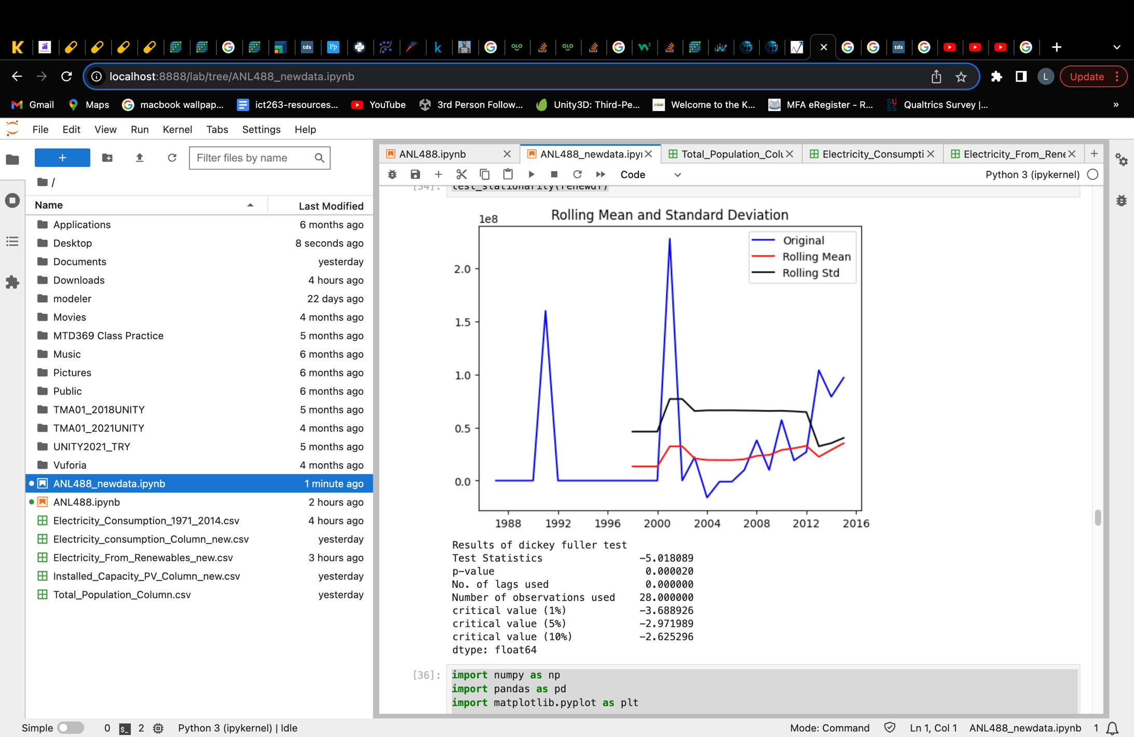

##### *Figure 2.6: Checking renewable electricity dataset for stationarity after 1st order differencing*

Compared to figure 2.4, figure 2.6 visually shows less of a upward trend. The p-value now is also smaller than 0.005 at 0.000020. The test statistics value of -5.01809 is also smaller than all 3 critical values. Hence, this suggests that this data is now stationary.

### **Singapore’s Total Population Dataset**

#### 1) Handling missing or null values

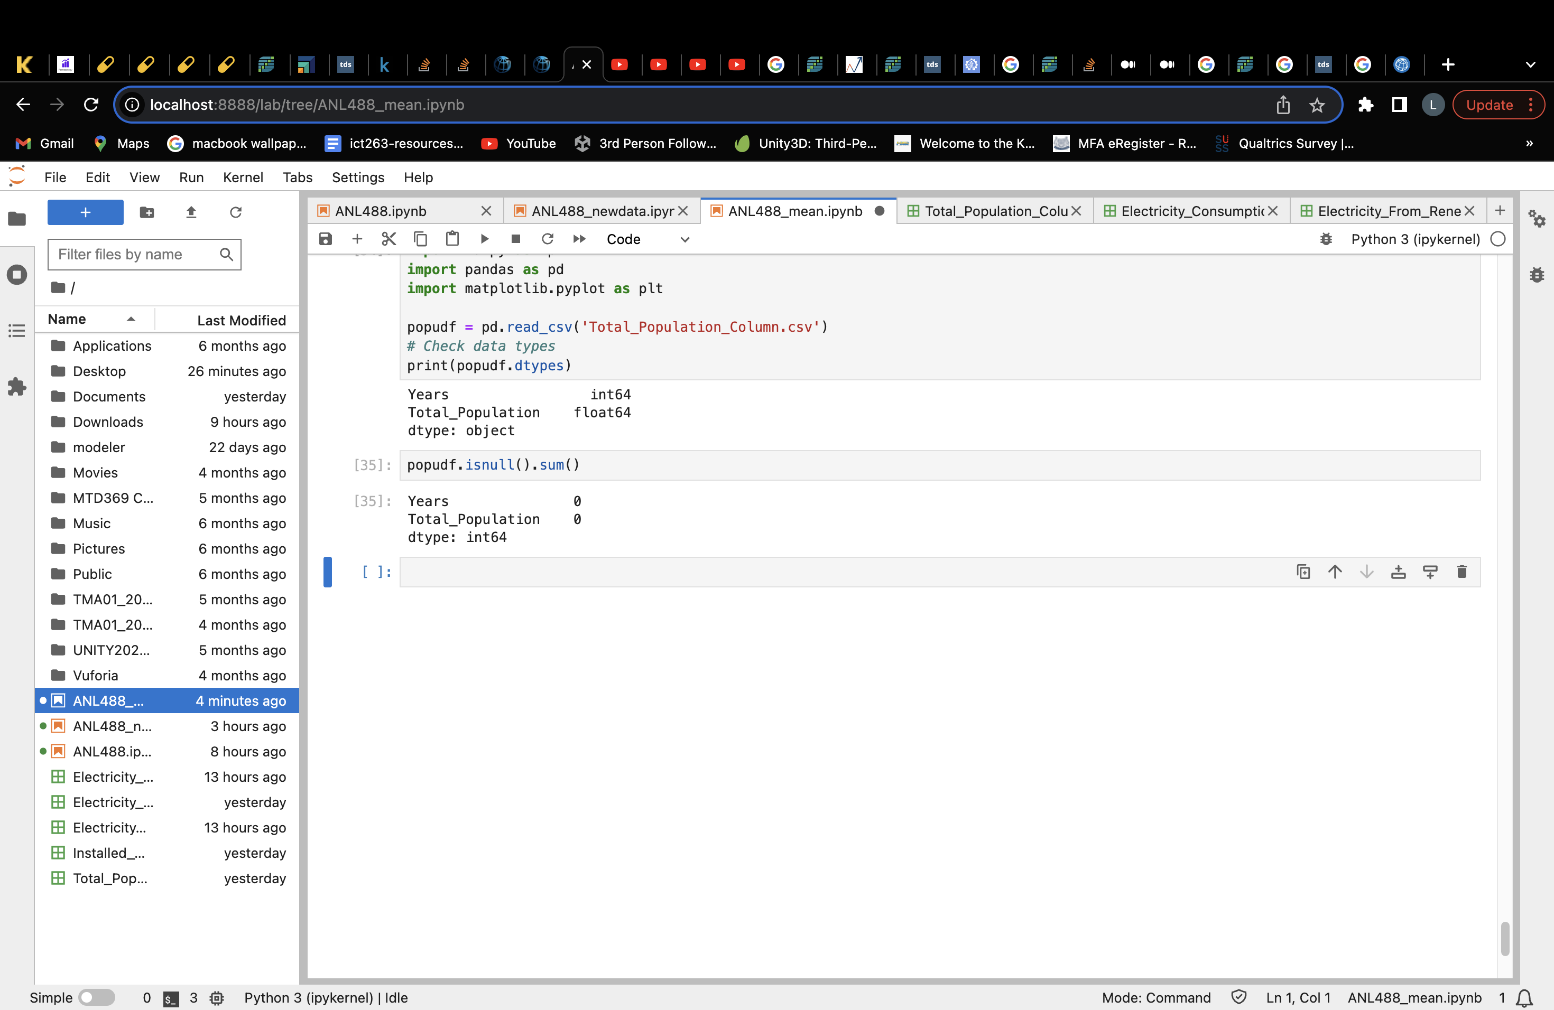

##### *Figure 3.1: Null values present in Total Population dataset*

Unlike the previous two datasets, this data does not have any null or missing values as can be seen from figure 3.1. Hence, this data consisting of 2 columns and 73 rows has no missing data needed to be discarded or replaced.

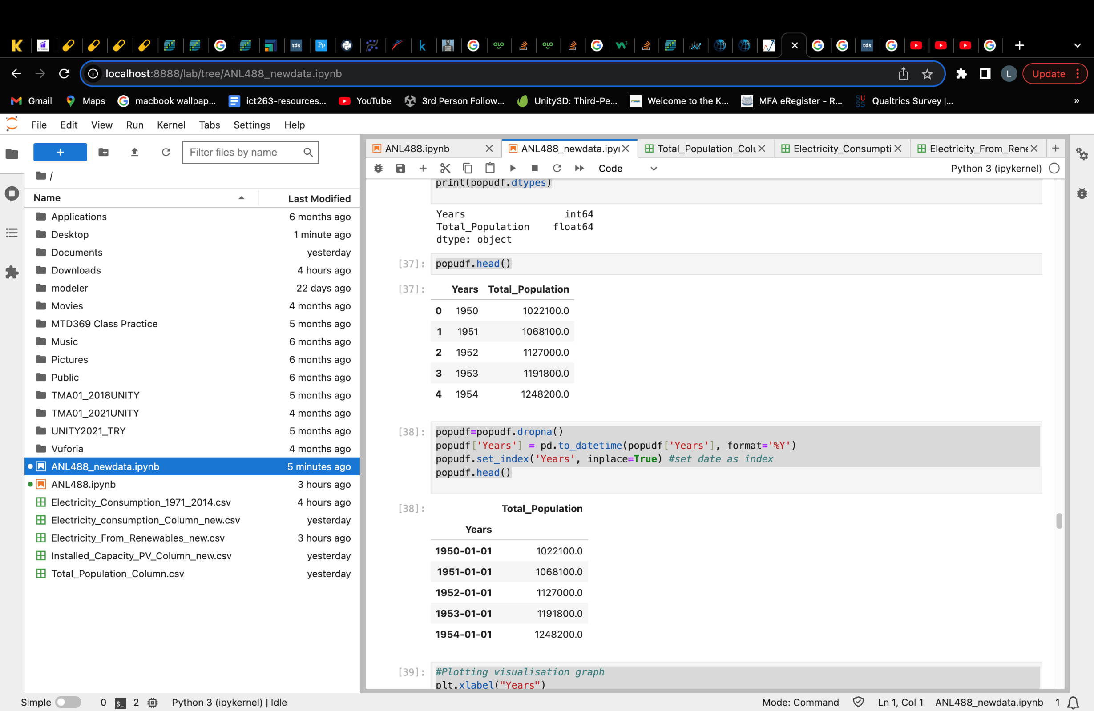

##### *Figure 3.2: Setting Total Population dataset’s time element as index*

Figure 3.2 shows the step the time element of the data is set to index in python in order to make the dataset applicable for forming a time series model.

#### 2) Check for stationarity

*Checking for stationarity* ***before*** *differencing*

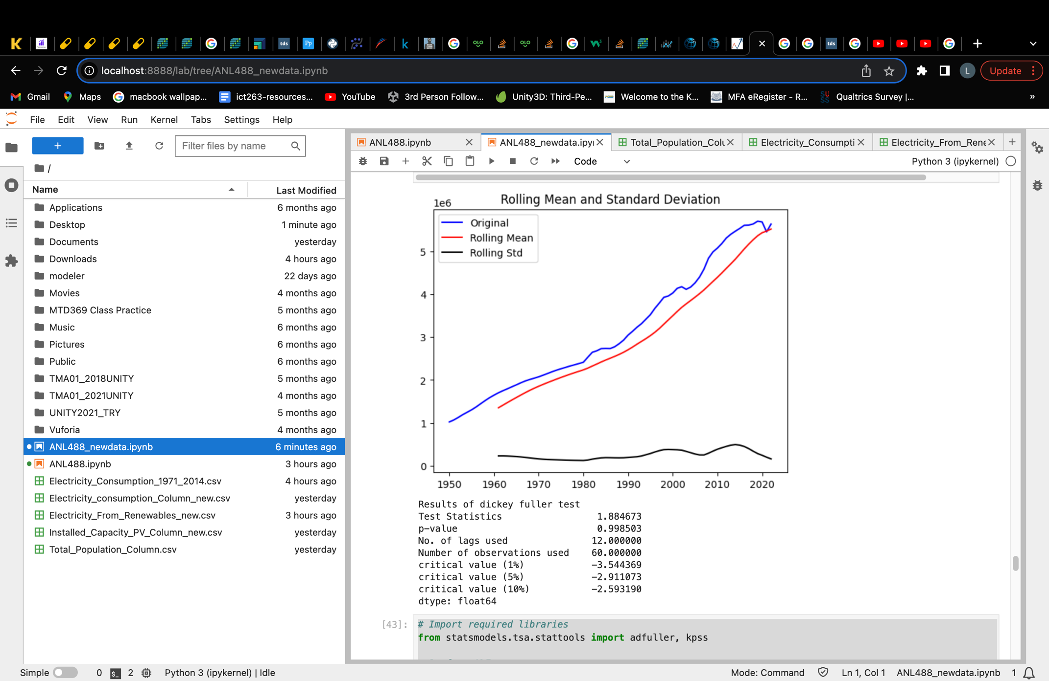

##### *Figure 3.3: Checking Total Population dataset for stationarity before differencing*

Figure 3.3 shows the results of the dickey fuller test conducted to investigate if the dataset is stationary before taking steps to ensure its stationarity. From the results, we can deduce that the dataset is not stationary.

This can be seen firstly, from the visual graph that this data has an upward trend. As we can see from the upward trending original line as well as the rolling mean line.

Secondly, we can deduce stationarity from the p-value generated where in this case is greater than the significance value 0.005. Thus, we would not reject the null hypothesis and deduce that this data is not stationary.

Lastly, we can also determine if the data is stationary by looking at whether the test statistics value is smaller than the critical values. Here, the test statistics is much bigger than all 3 critical values, hence indicating as well that the data is not stationary.

After deducing that the data has a trend and is not stationary, we will be using differencing in an attempt to remove the trend present and achieve stationarity for this dataset.

#### 3) Removing trend

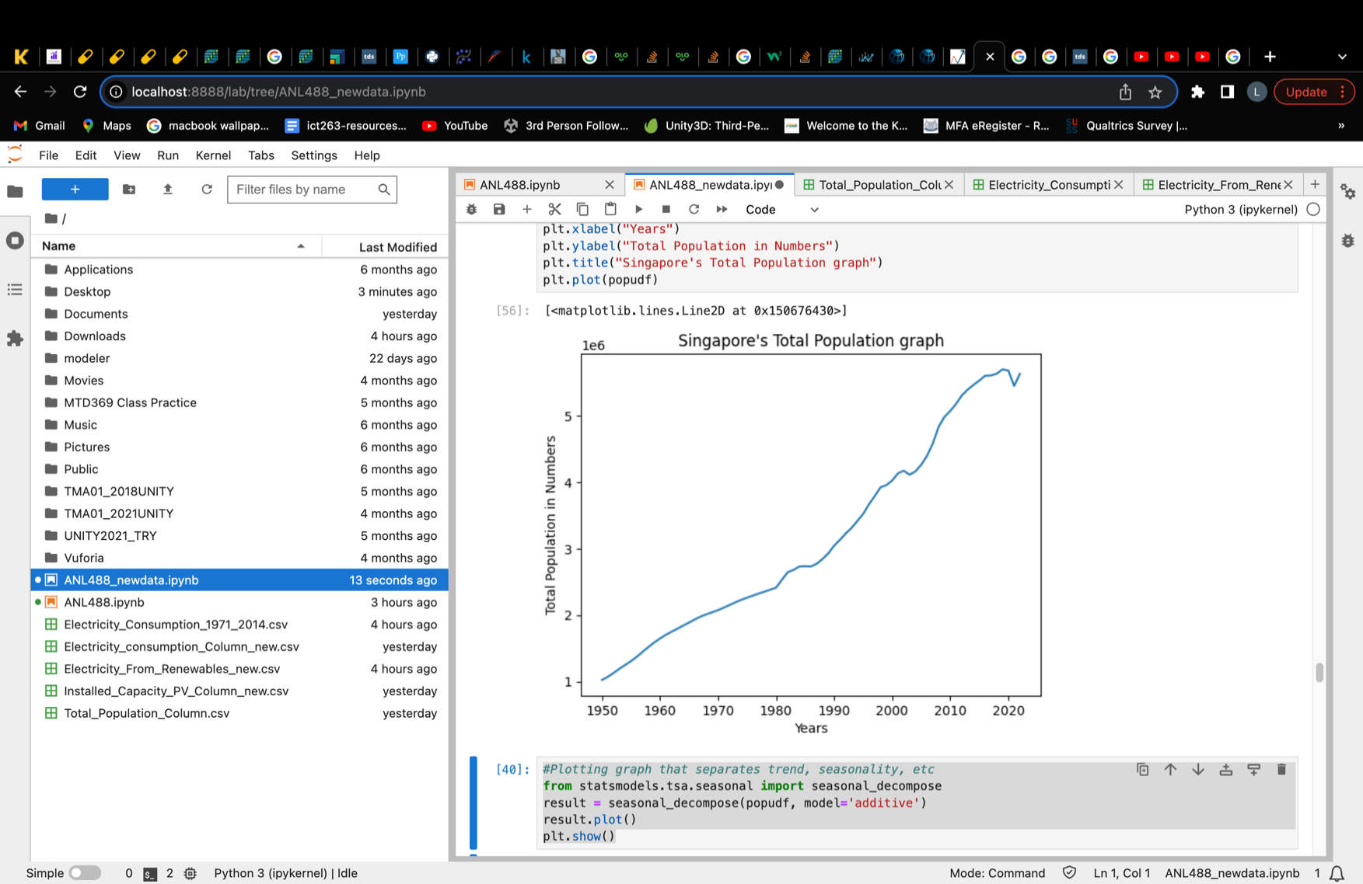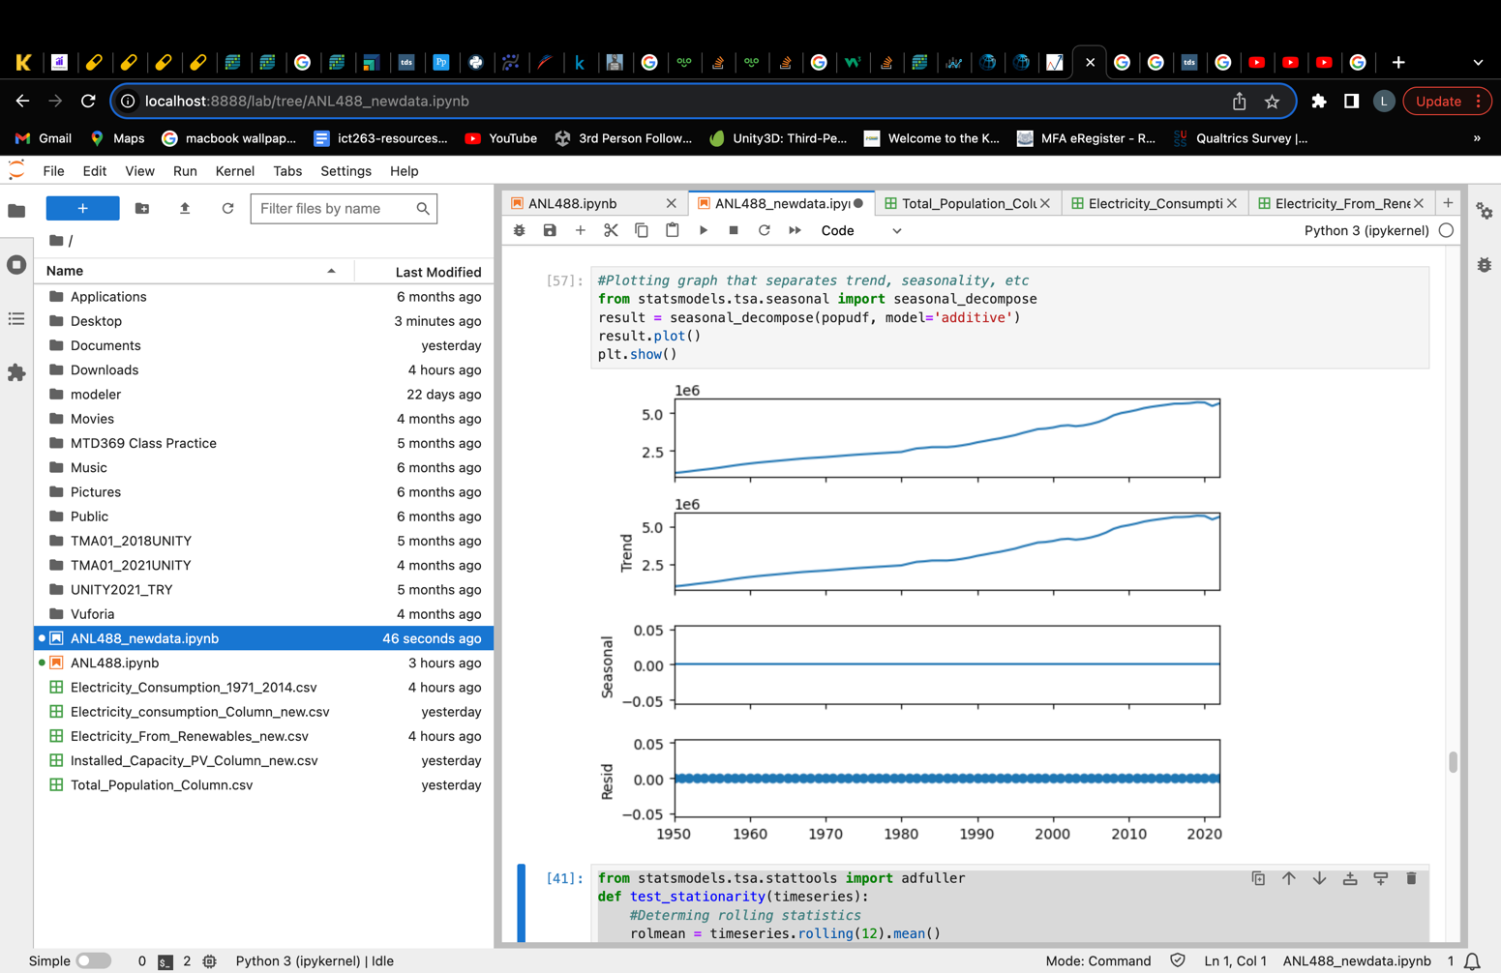

##### *Figure 3.4: Total Population dataset Visualisation Graphs*

Figure 3.4 shows the data visually presented on the left and seasonally decomposed to identify possible trends and seasonality on the right. From here, we can see that the data does consists an upward trend. However, seasonality is not see in the graph as expected, because this dataset contains yearly data that will unlikely show seasonality.

|  |  |
| --- | --- |
| P-value **before** differencing   | |
| P-value **after First Order** Differencing   | P-value **after Second Order** Differencing   |

##### *Table 4: Total Population data p-value after first and second order of differencing*

To remove the trend present, we conducted first and second order of differencing on the total population dataset. Table 4 shows the p-value results obtained before and after the first and second order of differencing using both the Augmented Dickey-Fuller (ADF) test and Kwiatkowski-Phillips-Schmidt-Shin (KPSS) test.

As observed from table 4, the p-value after the first order of differencing was 0.127 and 0.100 respectively for ADF and KPSS test. Although the KPSS test already accepted its null hypothesis of H0 = data is stationary as the p-value is larger than 0.005, the p-value for the ADF test still suggests that the data is not stationary as its p-value is still larger than 0.005. Hence, a second order of differencing is performed to further de-trend the data. After the second differencing, the p-value for the ADF test successfully became smaller than 0.005, suggesting that the data is now stationary.

The results showed p-value 0.002 and 0.100 for both tests respectively after the second order of differencing. Hence, both the ADF and KPSS tests are rejected and not rejected respectively, indicating that this data is now stationary. (The p-values here are only displayed to 3 decimal place)

#### 4) Removing Seasonality

After the trend is removed, seasonality needs to be removed as well, if applicable. However, as the total population dataset contains only yearly data, seasonality will not be present. This can be further supported by figure 3.4 where the seasonality in the seasonally decomposed graph on the right shows a straight line. Hence, as seasonality is not present in this data, there will be no need to perform steps to remove seasonality.

#### 5) Ensure stationarity

After removing possible trend and seasonality, we now need to ensure that the data has indeed achieve stationarity. To do so, a simple ADF test is performed again to ensure that the p-value of the differenced data is lower than the significance level of 0.005.

*Checking for stationarity* ***after*** *differencing*

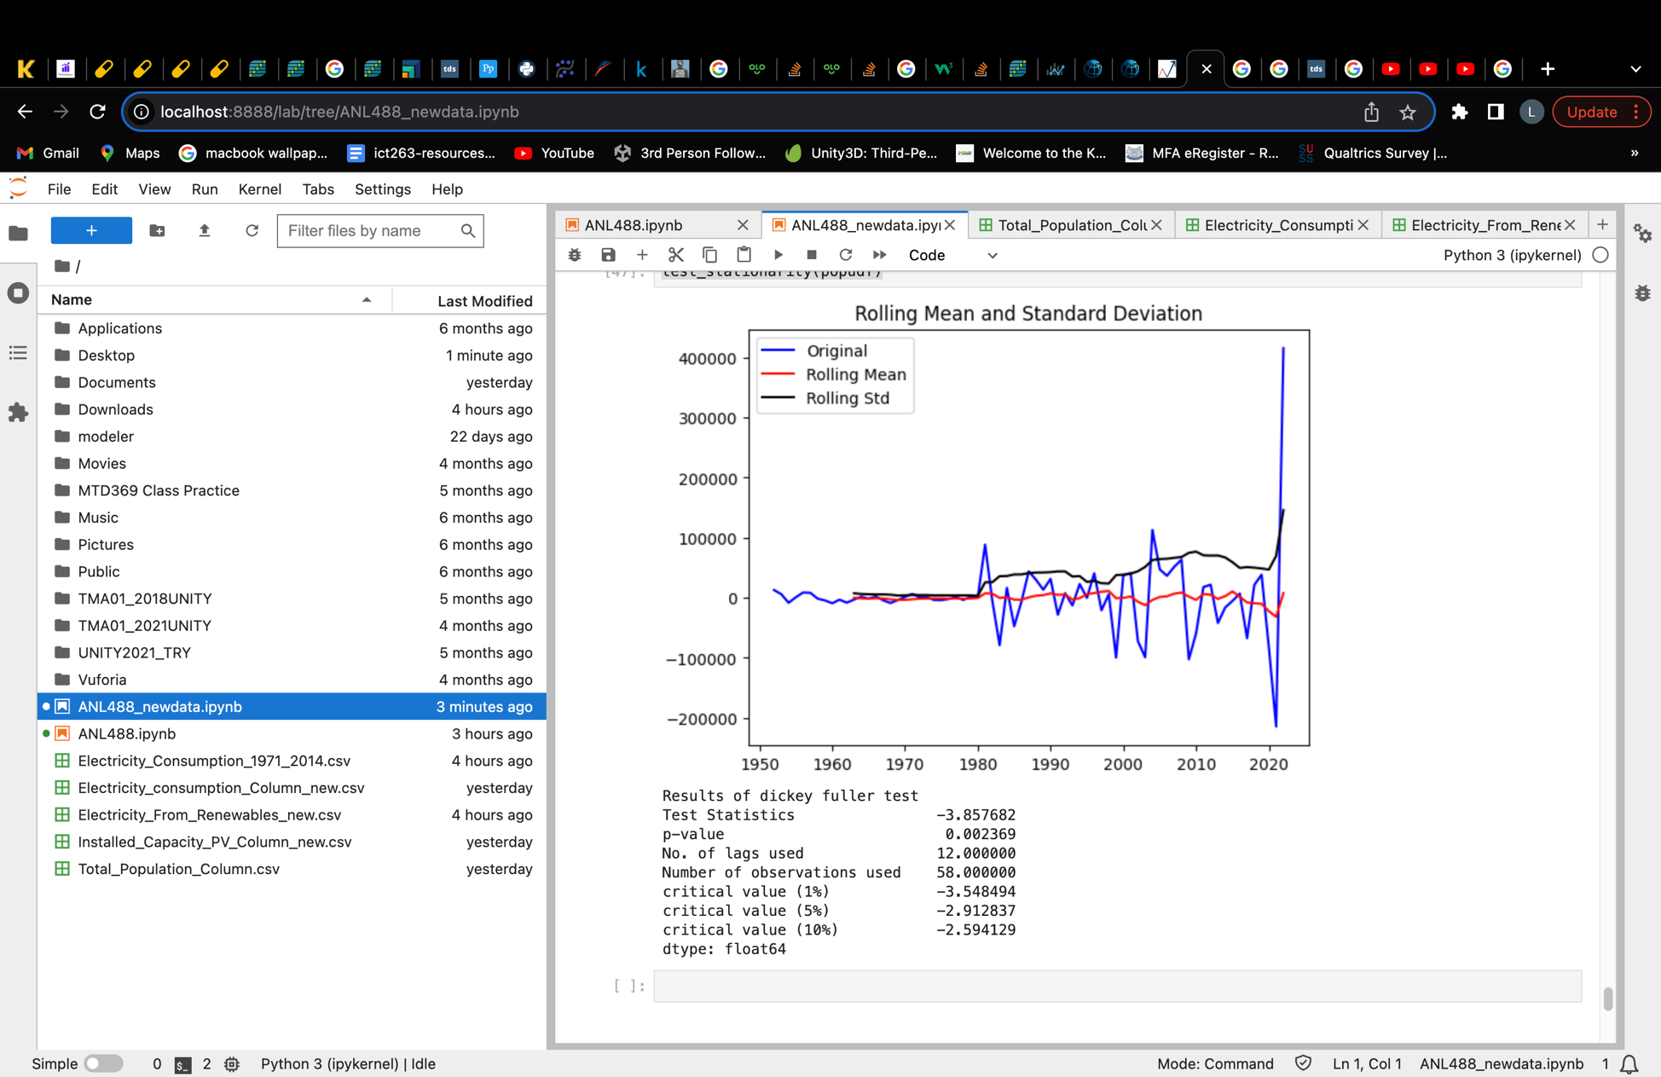

##### *Figure 3.5: Checking renewable electricity dataset for stationarity after 1st order differencing*

Compared to figure 3.3, figure 3.5 visually shows less of a upward trend where most values lies around the 0 point. The p-value now is also smaller than 0.005 at 0.002369. The test statistics value of -3.857682 is also smaller than all 3 critical values. Hence, this suggests that this data is now stationary.

# **Proposed Modelling and Evaluation**

As our study focuses on time series analysis, models such as Single (SES), double (Holt’s) and triple exponential smoothing (Holt-winter’s), AR, MA, ARIMA, ARMA, SARIMA and SARIMAX are considered. However, as our data does not contain seasonality, models specialising in seasonality such as Holt-winter’s method, SARIMA and SARIMAX would be ruled out of this study. Single exponential smoothing used for dataset with no trend and seasonality will also be ruled out of this study as our dataset shows signs of trend present. (Otext, 2023) The ARMA model will also be ruled out as differencing was conducted on all 3 datasets in order for all data to be stationary, hence ARMA which works better on stationary datasets would be ruled out as our datasets were non-stationary to begin with. (Mills, 2019) Both the AR and MA models will not be studied as standalone models in this study as the ARIMA model containing both the AR and MA model will be used instead. Hence, this study will focus on 2 models namely, the ARIMA model and Holt’s method.

To determine which model would be finalised, a comparison of the various model’s accuracy and performance based on their MSE, MAPE and AIC values would be done to determine which model will be the best suited model for the respective dataset.

## *ARIMA MODEL*

An Auto-regressive integrated moving average (ARIMA) model is the most general model used in time series forecasting. It forecasts future values by using forecast errors and/or past values. (Lianne & Justin, 2022) This model works best if data is stationary, with no seasonality with one variable (univariate). (*Univariate time series analysis*, 2022) Hence, this modelling technique will be a great candidate for our datasets.

An ARIMA model is made up of three components namely:

1. Autoregression (AR)
2. Differencing (I)
3. Moving Average (MA)

These three components make up an ARIMA model where it is presented as ARIMA(p, d, q). The p represents the AR model which indicates autoregressive term, d represents the number of time the data was differenced and q represents the MA model which indicates the number of moving averages or error terms. (linkedin, 2023)

The order of the ARIMA model will be determined based on the model’s ACF, order of differencing performed and PACF. These will determine the ARIMA model’s p, d, q values respectively.

Hence, a PACF and ACF plot would be produced for each dataset to manually determine a suitable order of ARIMA model before model construction.

## *HOLT’S METHOD*

As an extension from single exponential smoothing (SES), the Holt’s method also known as double exponential smoothing builds on the SES model by adding a trend smoothing component. (Brownlee, 2020) It is useful in predicting data without seasonality but with trend which is perfect since our datasets exactly contains only trend, without seasonality.

The hyperparameters in this model includes:

* Alpha: Smoothing the level of the data
* Beta: Smoothing the trend of the data
* Trend Type: Additive / Multiplicative
* Dampen Type: Additive / Multiplicative
* Phi: Damping Coefficient

The above proposed models will be evaluated by their MAPE and MSE evaluation values. These two evaluation values are chosen to determine which model has the lowest error.

The Mean Absolute Percentage Error (MAPE) value helps us to evaluate the model’s performance based on the % of error the model has. It is essentially the average absolute percentage difference between the actual and predicted values and hence, a smaller MAPE value would suggest a better performing model. (Allwright, 2022) The Mean Squared Error (MSE) places more weight on large errors. It is the mean squared difference between the actual and predicted values. Hence, a smaller MSE value suggests a model with lesser error and better performance. (*Mean squared error*, 2021)

The evaluation values will be presented through a comparison table below:

## ***Model Comparison Table***

|  |  |  |
| --- | --- | --- |
| Models | MAPE | MSE |
| ARIMA |  |  |
| Holt’s Method (DES) |  |  |

The model with the best evaluation values will be selected for the respective dataset.

After evaluating the best model for all three datasets, prediction would be conducted to predict the respective values to year 2030. After prediction is complete, an analysis on the results would be conducted to deduce

1. if the level of predicted renewable electricity generation is able to supplement the baseline of 60% of the predicted electricity consumption level in the same time period.
2. The prediction of population would be analysed with the predicted electricity consumption values to realise any relationship between these two variables.

From here, we would finalise if Singapore is able to rely on renewable electricity and whether the increase in population would affect electricity consumption levels in the nation. Actionable steps that factor in Singapore’s constraints towards renewable electric generation would also be discussed. Hence, this proposal serves as a guide for readers to understand the rationale behind this study.

# **Proposed Schedule**





# **References**

Allwright, S. (2022, December 6). *What is a good MAPE score? (simply explained)*. Stephen Allwright. https://stephenallwright.com/good-mape-score/

Asadi, M., Larki, I., Mohammad, M. F., Ahmadi, R., & Farajollahi, M. (2023). Long-Term Scenario Analysis of Electricity Supply and Demand in Iran: Time Series Analysis, Renewable Electricity Development, Energy Efficiency and Conservation. Sustainability, 15(5), 4618. https://doi.org/10.3390/su15054618

Brownlee, J. (2020a, April 12). *A gentle introduction to exponential smoothing for time series forecasting in Python*. MachineLearningMastery.com. https://machinelearningmastery.com/exponential-smoothing-for-time-series-forecasting-in-python/

Brownlee, J. (2020b, August 14). *How to difference a time series dataset with python*. MachineLearningMastery.com. https://machinelearningmastery.com/difference-time-series-dataset-python/#:~:text=Differencing%20can%20help%20stabilize%20the,or%20reducing)%20trend%20and%20seasonality.&text=Differencing%20is%20performed%20by%20subtracting%20the%20previous%20observation%20from%20the%20current%20observation.&text=In%20this%20way%2C%20a%20series%20of%20differences%20can%20be%20calculated.

Department Of Statistics Singapore. (2023). *Singapore Statistical System - Who We Are*. DOS SingStat. https://www.singstat.gov.sg/who-we-are/singapore-statistical-system#:~:text=Singapore%20has%20adopted%20a%20decentralised,government%20ministries%20and%20statutory%20boards.

Energy Market Authority - EMA. (2023). *Industry Liscence*. Energy Market Authority - EMA. https://www.ema.gov.sg/regulations-licences/licences/industry-licences

Goh, T. (2020, October 14). *Parliament: Increased household electricity and gas consumption from April to July due to Covid-19 measures*. Retrieved from straitstimes.com: https://www.straitstimes.com/singapore/politics/parliament-increased-household-electricity-and-gas-consumption-from-april-to-july

G, V. K. (2023, June 6). *Statistical tests to check stationarity in time series*. Analytics Vidhya. https://www.analyticsvidhya.com/blog/2021/06/statistical-tests-to-check-stationarity-in-time-series-part-1/#:~:text=A%20Stationary%20series%20is%20one,a%20Trend%20or%20Seasonal%20components.

Iea. (2023). *International Energy Agency - About*. About IEA - International Energy Agency. https://www.iea.org/about

Jaisumroum, N., & Teeravaraprug, J. (2017). Forecasting uncertainty of Thailand’s electricity consumption compare with using artificial neural network and multiple linear regression methods. 2017 12th IEEE Conference on Industrial Electronics and Applications (ICIEA), 308–313. https://doi.org/10.1109/ICIEA.2017.8282862

Kumar, S. (2022, January 18). *ML algorithm that natively supports missing values*. Medium. https://towardsdatascience.com/ml-algorithm-that-natively-supports-missing-values-40b42559c1ec#:~:text=Most%20of%20the%20machine%20learning,based%20Gradient%2Dboosting%20Classifier%20%2F%20Regressor

Kuo, G. (2019, August 23). When fossil fuels run out, what then?. MAHB. https://mahb.stanford.edu/library-item/fossil-fuels-run/#:~:text=Yes%2C%20we%20are%20rapidly%20depleting,renewables%20and%20remainder%20by%20nuclear.

Lianne, & Justin. (2022, August 25). *How to build Arima models in Python for time series prediction*. Just into Data. https://www.justintodata.com/arima-models-in-python-time-series-prediction/

linkedin. (2023). *What are the advantages and disadvantages of Sarima models over Arima models?*. SARIMA vs ARIMA Models: A Comparison Guide. https://www.linkedin.com/advice/0/what-advantages-disadvantages-sarima-models#:~:text=There%20is%20no%20definitive%20answer,any%20seasonal%20patterns%20or%20trends.

Manni, U. H., & Mansur, D. K. H. M. (2022). AN INVESTIGATION OF INDONESIA'S TRANSITION TOWARDS RENEWABLE ENERGY USING TIME SERIES ANALYSIS. Journal of Energy and Development, 47(2), 297-325,335-336. https://www.proquest.com/scholarly-journals/investigation-indonesias-transition-towards/docview/2768535344/se-2

*Mean squared error: Definition and example*. Statistics How To. (2021, June 26). https://www.statisticshowto.com/probability-and-statistics/statistics-definitions/mean-squared-error/

Mills, T. C. (2019, January 25). *Arma models for Stationary time series*. Applied Time Series Analysis. https://www.sciencedirect.com/science/article/abs/pii/B978012813117600003X

Otext. (2023). *Forecasting: Principles and practice (2nd ed)*. 7.1 Simple exponential smoothing. https://otexts.com/fpp2/ses.html

Pannakkong, W., Harncharnchai, T., & Buddhakulsomsiri, J. (2022). Forecasting daily electricity consumption in Thailand using regression, artificial neural network, support vector machine, and hybrid models. Energies, 15(9), 3105.

PennState - Eberly College of Science. (2023). *5.1 decomposition models: Stat 510*. PennState: Statistics Online Courses. https://online.stat.psu.edu/stat510/lesson/5/5.1#:~:text=How%20to%20Choose%20Between%20Additive,seasonal%20variation%20increases%20over%20time.

Powering Lives (2023, August 18) Singapore’s Energy Journey. https://www.poweringlives.gov.sg/about/singapore-energy-story/

Rasheed, R. (2020, July 12). *Why does stationarity matter in time series analysis?*. Medium. https://towardsdatascience.com/why-does-stationarity-matter-in-time-series-analysis-e2fb7be74454

Rekhade, R., & Sakhare, D. K. (2021). Forecasting sector-wise electricity consumption for India using various regression models. Current Science, 121(3), 365.

The World Bank. (2023). *The World Bank - Data Catalog*. World Development Indicators. https://datacatalog.worldbank.org/search/dataset/0037712

Shinn, L. (2022, June 1). Renewable energy: The clean facts. Renewable Energy Definition - Sources, Clean Alternatives. https://www.nrdc.org/stories/renewable-energy-clean-facts#sec-whatis

Sozen, A. (2009). Future projection of the energy dependency of Turkey using artificial neural network. Energy Policy, 37(11), 4827–4833. https://doi.org/10.1016/j.enpol.2009.06.040

*Univariate time series analysis and forecasting with Arima/Sarima*. Section. (2022, May 11). https://www.section.io/engineering-education/univariate-time-series-analysis-with-arima-in-python/

Yoo, S.-H. (2006). The causal relationship between electricity consumption and economic growth in the ASEAN countries. Energy Policy, 34(18), 3573–3582. https://doi.org/10.1016/j.enpol.2005.07.011